EXP- 1
Create a Kanban Board (Jira/Trello)
Aim
To create and simulate a Kanban workflow using Jira or Trello.
Procedure
1. Login to Jira/Trello.
2. Create a new Kanban board.
3. Create columns: To Do, In Progress, Done.
4. Add 2 to 3 tasks.
5. Move tasks across columns to simulate workflow.
6. Observe task progress.
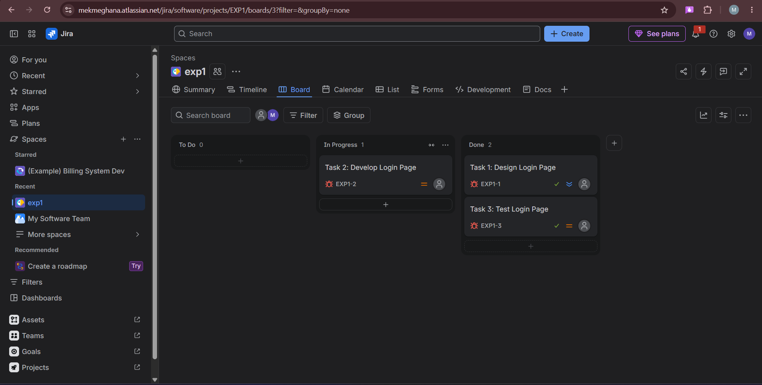

Result: Thus, The Kanban board has created successfully and simulated workflow by moving tasks across stages.

EXP- 2
Bus Ticket Booking Prototype (Figma)
Aim
To design a simple Bus Ticket Booking System prototype using Figma.
Procedure
1. Open Figma and create a new design file.
2. Design screens:
• Home Page
• Search Bus
• Seat Selection
• Payment Page
3. Add navigation links.
4. Present prototype mode.
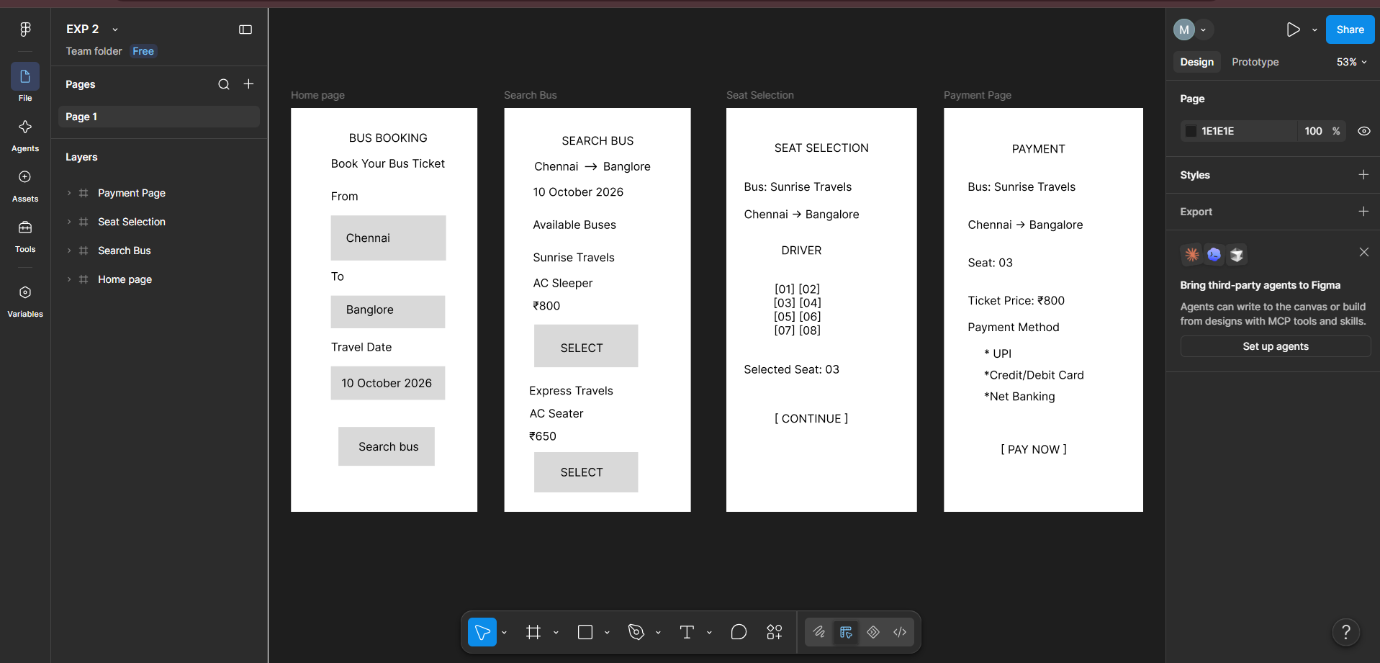
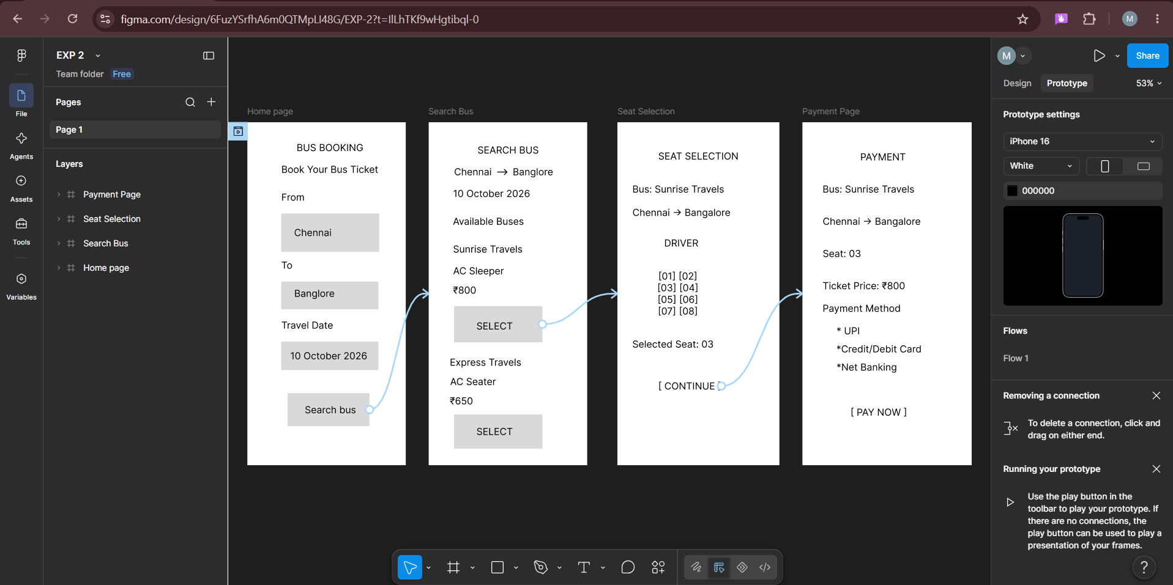
Result: Thus, The clickable prototype of Bus Ticket Booking System was created successfully.
EXP-3
E- Commerce Mobile App Prototype (Figma)
Aim
To design a prototype for stakeholder feedback.
Procedure
1. Create mobile frame in Figma.
2. Design Home, Product Page, Cart, Checkout.
3. Create two UI variations (to resolve conflict).
4. Present to stakeholders for feedback.
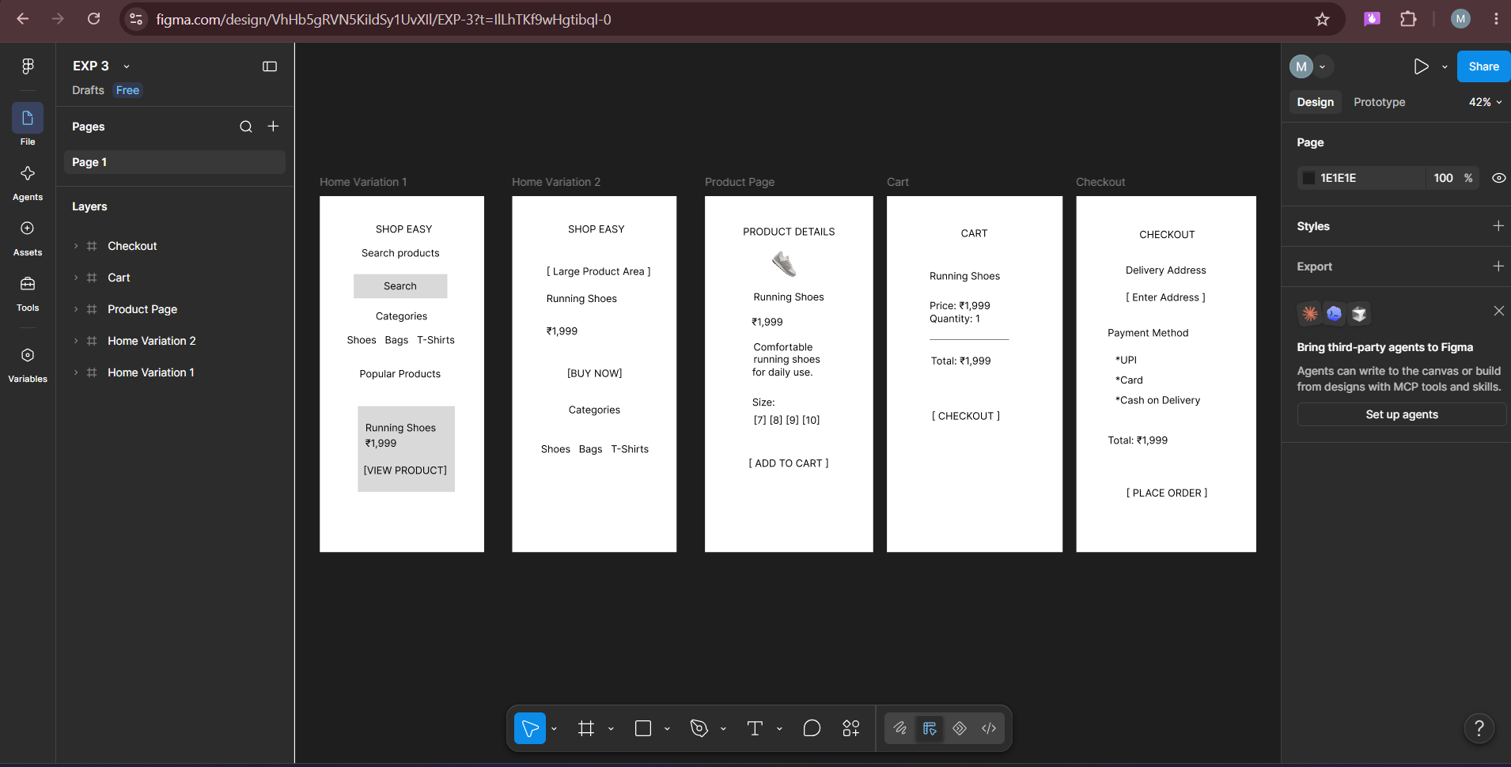
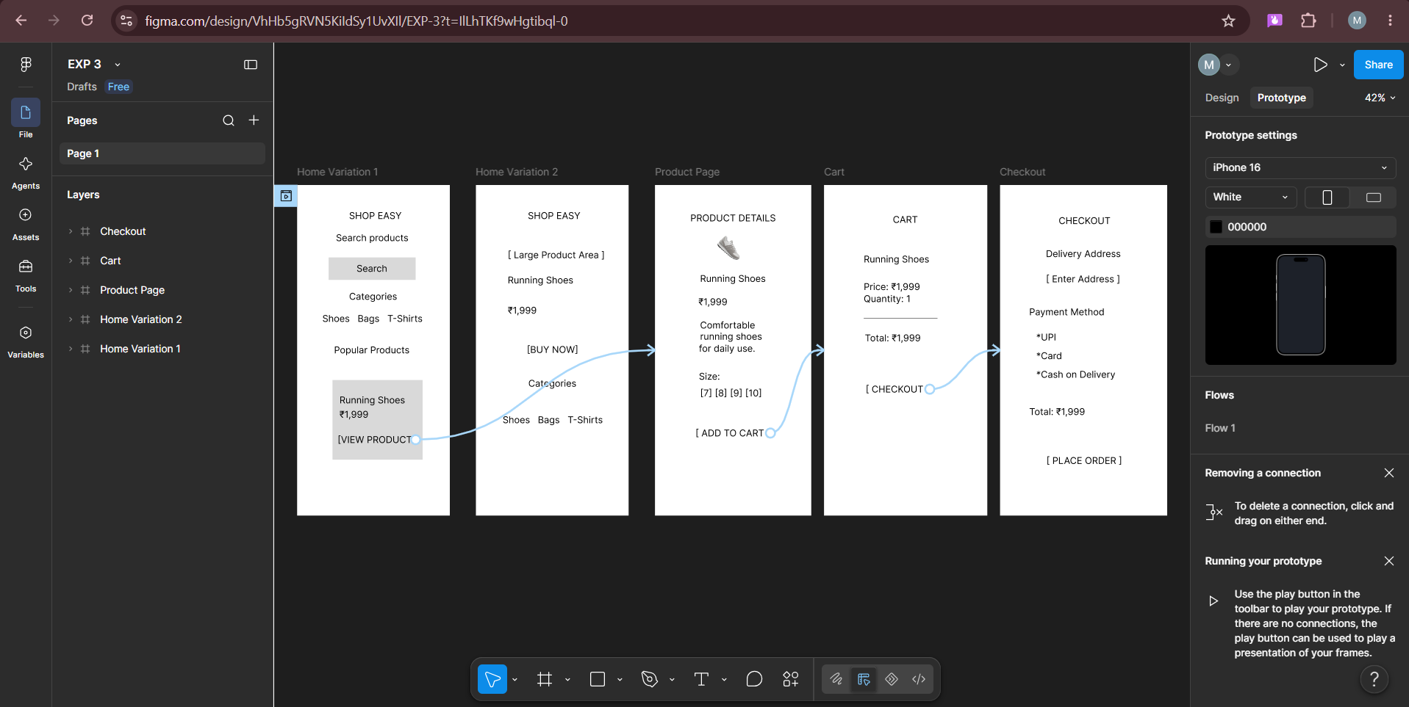

Result: Thus, The Prototype created and stakeholder feedback collected for UI finalization.

